Read “ETF_Market_Value_vs_NAV” document first to make sure you understand what the NAV of an ETF means.
The expense ratio is how much you pay an ETF company per year, expressed as a percent of your investments. So, if you have $5,000 invested in an ETF with an expense ratio of 0.04%, you'll pay the fund $2 annually.
The expense ratio of an ETF includes various operational costs and annual fees, such as:
- Administrative fees.
- Compliance fees.
- Management fees.
- Marketing fees.
- Record-keeping fees.
- Auditing fees.
- Legal fees.
- Shareholder service fees.
The expense ratio of an ETF is an annual fee that is, in fact, deducted from the NAV of the ETF, so investors do not see these fees on their statements because the ETF’s company handles them in-house. So, the expense ratio of an ETF is one of the liabilities that appear in the NAV formula. So, at the end of each trading day, the ETF’s company calculates all the ETF’s underlying assets (including cash), then subtracts from it the expense ratio of the ETF, and finally divide by the shares outstanding to give the NAV of the ETF. Of course, the higher the expense ratio of an ETF, the larger the value deducted from the total assets, and hence the less its NAV. Since the NAV affects the market value of an ETF, this means that, the larger the expense ratio of an ETF, the less the increase in the market value of the ETF, hence the less your profits. This is why your profit from an ETF decreases as the expense ratio increases because this expense ratio is subtracted from the total profits that the ETF makes.
  - Example
Assume an ETF has a stated annual expense ratio of 0.75%. Assume an investor is investing $50,000 in this ETF. After 1 year, assume the ETF has made 0% profits (i.e. all its underlying assets’ price didn’t change). So, ideally, the investor should see his $50,000 as it is. However, since there is an 0.75% expense ratio, the ETF’s NAV will drop by 0.75%, so the investor’s $50,000 will become $49,625. See? The expense ratio is reflected in the ETF’s price, not deducted from the investor’s account. Notice that the investor’s money will drop from $50,000 to $49,625 gradually over the year since the ETF’s NAV is calculated at the end of each year. So, the investor’s money will indeed drop by $\frac{\$50,000-\$49,625}{365}=\$1.027$ every day.
VIP: notice that the expense ratio of an ETF is included in its NAV, which reflects on the ETF’s market price. This means that, when comparing different ETFs, their expense ratio is already included in their market price and hence you don’t need to bother yourself about it in the comparison! For example, we know that both VOO and SPY do the same exact thing; they track the S&P 500 index. However, when we compare between them as shown below, you can see that they are almost identical, but VOO has a very small higher performance. Why? Because SPY’s expense ratio is 0.09%, while that of VOO is only 0.03%.
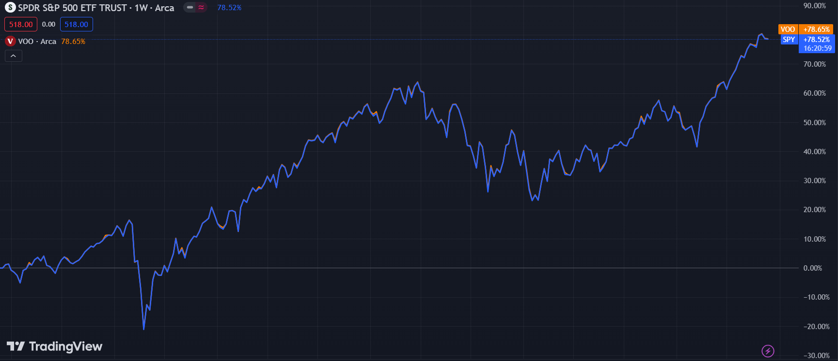
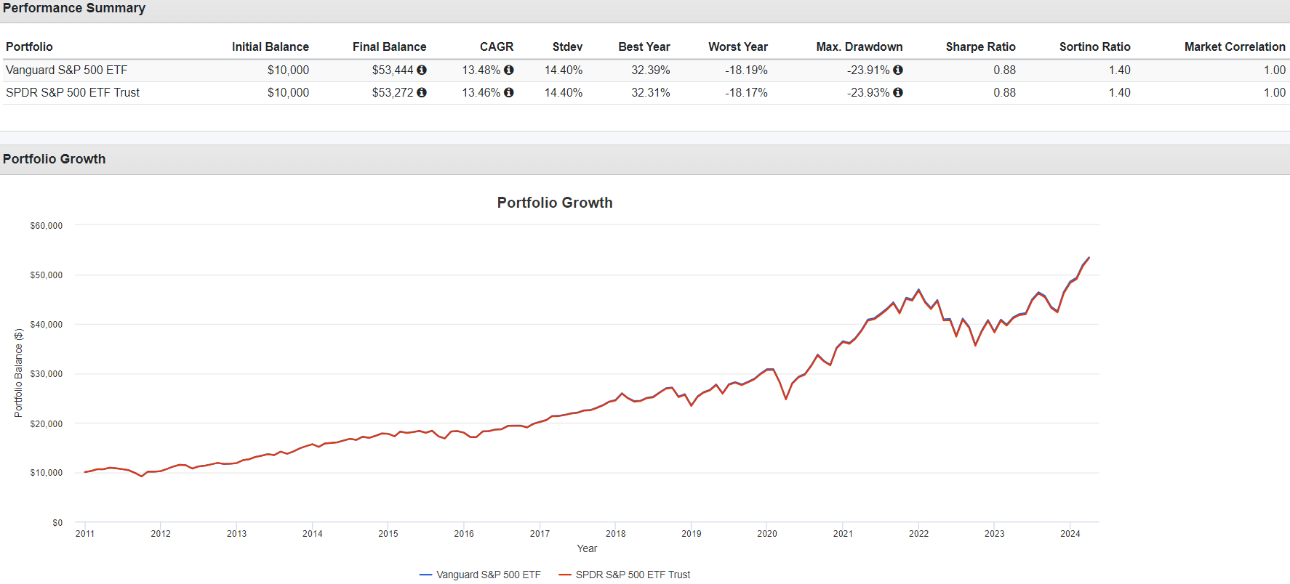
So, in my opinion, the best way to compare between ETFs is to use portfoliovisualizer.com and enable the “reinvest dividends” option. This way, you don’t need to bother yourself neither about the expense ratio of the ETF nor whether the underlying companies pay dividends or not.

